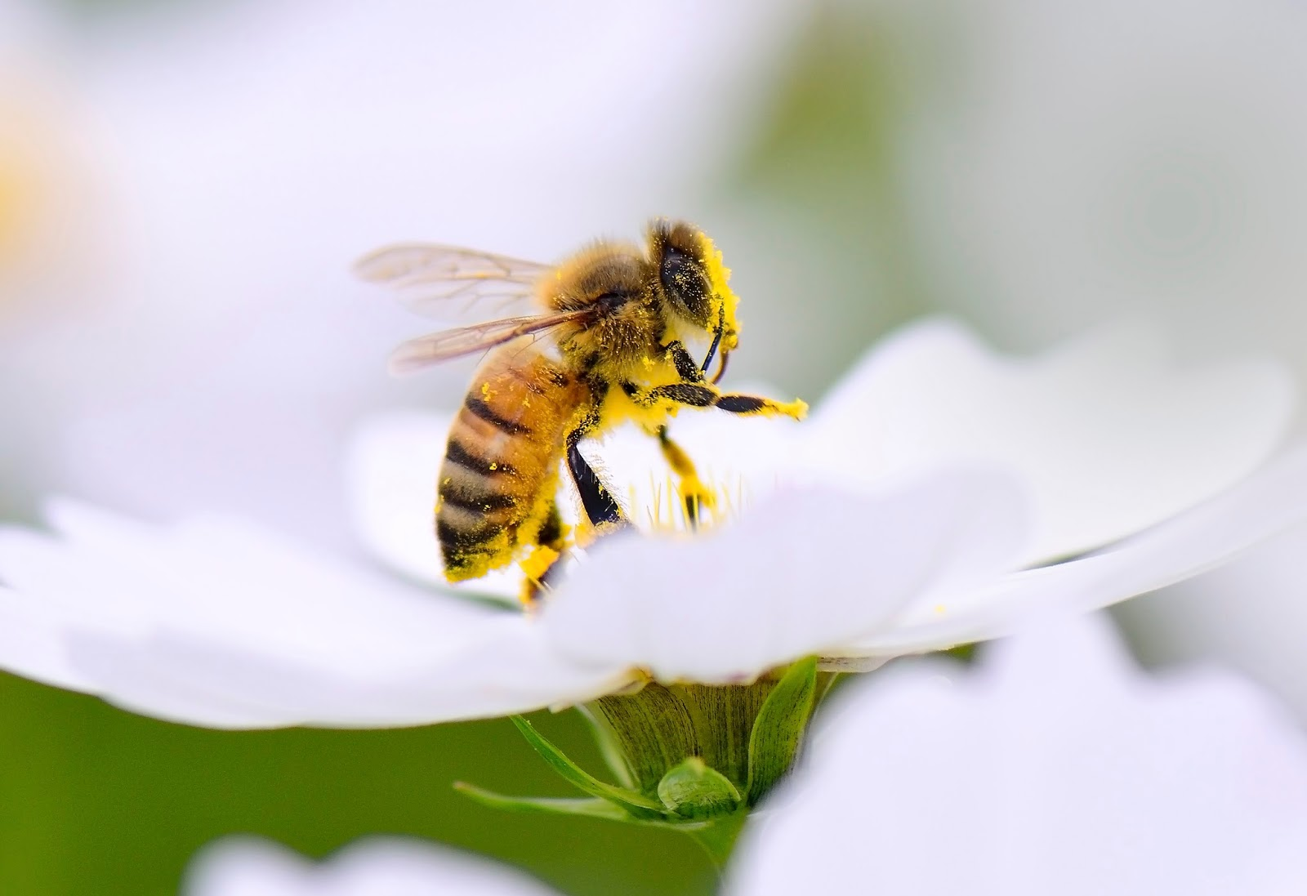
Extinction of Honeybees in America: The Repercussions from Neglecting to Preserve this Essential Pollinator

Ye Wu
February 11, 2016
UWP 102G
Word Count: 1781

Abstract

Within the last decade, the honeybee population has been falling at a rapid speed and the bee colonies are collapsing due to the bee extinction. Bee extinction is mainly caused by three key factors: advanced pesticides, recent climate changes, and an invasive virus. The whole food chain system will fall apart, triggering plants to die out and inevitably, a food shortage complemented with increased food prices will occur. Considering this will create substantial impact on the ecosystem and citizens of America, it is evident something needs to be done. Pesticide control, using more efficient energy to reduce effects of global climate change, and producing mite-free bees straight out of American soil is the most efficient way to restore the honeybee population and how life used to be.
Problem Statement
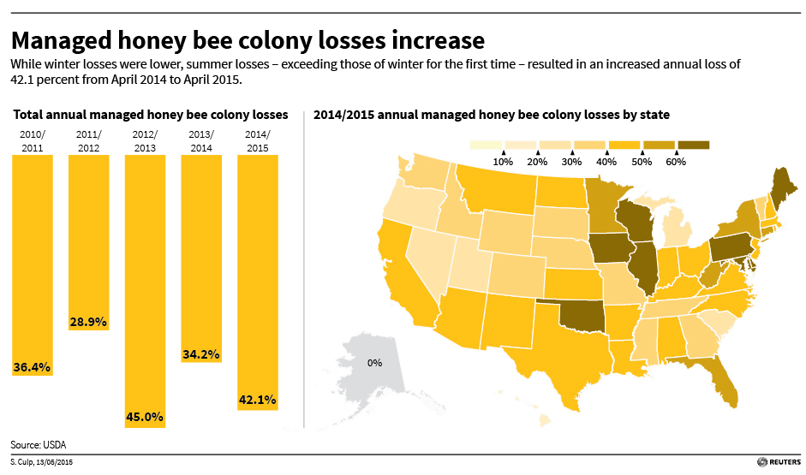
Although 130 fruits and vegetables depend on honeybee pollination, their significance to human beings is rarely talked about. People are naive and uneducated when it comes to the subject of bees and pollination. Since 2006, there has been a recorded 40% yearly loss in commercial honeybees according to data collected from the National Beekeeper Association in America. In more recent data, a third of honeybee colonies died or mysteriously disappeared over the last winter months in 2015.

Neonicotinoids:
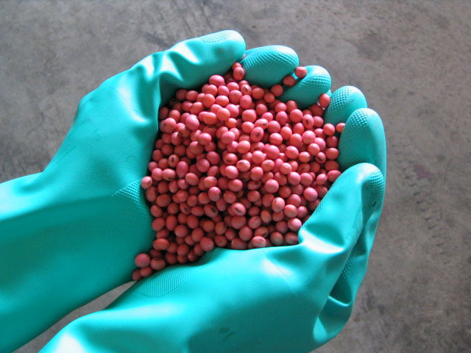
The greatest culprit is led by modern-day pesticides called neonicotinoids, created by one of the largest German-based biotech companies, Bayer. Neonicotinoids are a form of revolutionary pesticides which are sprayed on seeds before planting. When exposed, the bees have shown inability to return to their colonies and eventually die while spreading the pesticidal dust to other bees. Commercial honeybees, whom are strictly used for their marketing abilities have shown a decrease in sales due to 70% traces of neonicotinoids detected in their collected pollen and honey. Studies have been conducted to prove that taking organic pollen and local honey improves severe allergy symptoms. Farmers rely greatly on neonicotinoids to produce fruits and vegetables which visually look appealing to the eye; they can’t risk bringing peaches with holes or larvae-laid kale to the market, no one would buy it. The hesitation for any action to be taken will lead to the devastating extinction of honeybees which we solely rely on for food as well as from an economic standpoint.

Climate Change:
The change in climate patterns have also affected the bees’ wellbeing significantly by disrupting the year round pollination cycle that bees are accustomed to. Flowers are now blooming at earlier times than normal due to warmer temperatures causing bees to have limited nectar when they actually start pollinating. Moreover, the warmer temperatures have led to droughts throughout the year and water in the soil is evaporated rather than retained. Bees require little water to survive but flowers on the other hand survive mainly off water, sun, and nutrients from the soil. With little to no rain and absence of moisture in the ground, flowers are unable to grow. Therefore, the bees aren’t getting the proper amount of food required for survival; concurrently the flowers lose reproduction opportunities in the same given year.

Deformed Wing Virus:
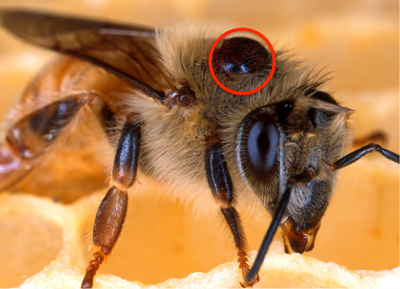
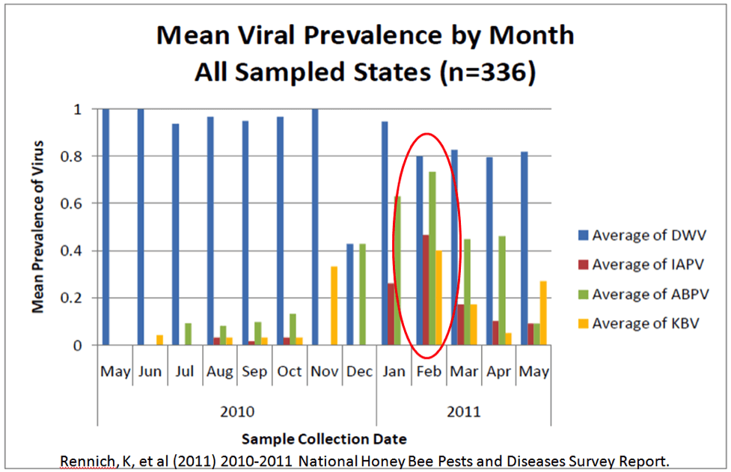
A third reason is due to the Deformed Wing Virus (DWV), an RNA-type virus caused by parasites known as varroa mites which attach themselves on bees (shown in the figure on the right). 2,000 varroa mites can cause the death of 30,000 honeybees when contact is made through feeding or reproduction. Affected bees have visibly shriveled wings or no wings at all; the bees will eventually be unable to fly properly, thus making it impossible to feed on nectar and gain energy to pollinate. Despite the fact that 22 viruses and fungal bacteria affect honeybees, 88% of honeybees found dead were diagnosed with this virus in a study conducted in 2008. The graph to the left shows several viruses that affect bees, the blue car being DWV. The Science journal reported that Deformed Wing Virus pathogen has increased in spreading frequency from 10 to 100%. This is due to DWV’s deadly ability to mutate and lower the bees’ immune system to be susceptible to other deadly viruses (shown on graph).

Significance
Albert Einstein once said “If the bee disappears from the surface of the earth, man would have no more than four years to live. No more bees, no more pollination … no more men!” More than one-third of our food supply is attributed by honeybee pollination. Staple foods including but not limited to apples, berries, onions, and tomatoes are crops pollinated by
bees which contribute up to $15 billion a year in crop value. The ongoing decreasing honeybee population will eventually lead to the extinction of such staple foods because one bee colony alone can pollinate over 300 million plants a day. Commercial bees which are raised in farms and shipped to other farms, in combination with wild bees, account for 80% of pollination for all United States crops. The commercial beekeeping industry has been suffering losses and soon
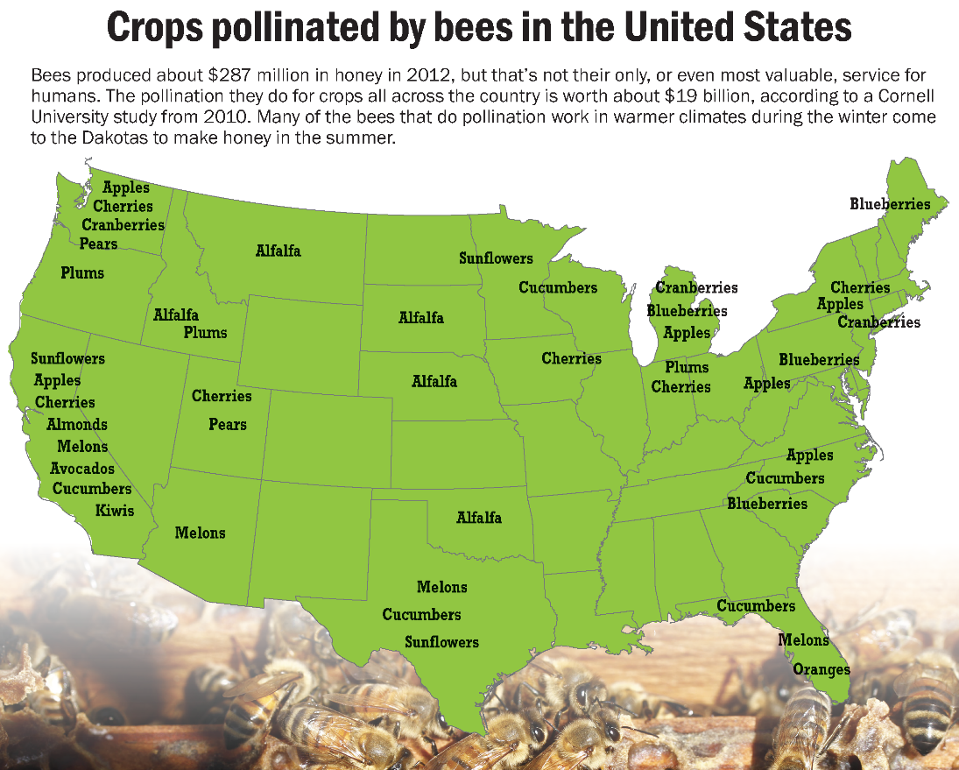
supermarkets will follow suit. In 2015 a couple Whole Foods stores emptied their shelves of products produced from bee pollination to emphasize the value of bees in supermarkets. Yogurt, milk, watermelon, and lemons were only a few of the items which were wiped out. The end result was half of the original store was left untouched; this painted a clear illustration for the necessity of bees in our ecosystem. Possible inferior-substitute pollinators such as butterflies, beetles, and dragonflies require a substantial amount of time and effort to function. Certain species of trees and flowers which are difficult to maintain, need to be cultivated near the produce in order to attract these insects. The honeybee population is becoming extinct which in turn will cause potential food shortage and inflated produce prices.

Stakeholders
Regarding honeybee extinction, the primary stakeholder group is the bees themselves. Due to vast usage of pesticides, climate change, and a virus, the bees have the largest impact and are dying at an increasing rate. Meanwhile, at the same rate, fruits and vegetables which they are pollinating in the season, have no substitute pollinators; without honeybees an estimated 150 crops will have no way of producing fruit. The second stakeholder group will be the farmers in America. Farmers rely on these crops to feed their family and maintain their farms. The farmers along with their families and farmhands will be affected and there’s nothing they can do about it if nothing is done right now to stop the ongoing extinction process.
Beekeepers will also be affected by bee extinction due to the reduction in their production of bees and related bee products; this will cause drastic financial problems. Consumers of honey and pollen will experience exponentially inflated prices for the products and ultimately there will be no products. The ecosystem will be affected by the extinction of bees as well, because bees are really important in the ecosystem. Without them, the food chain will have a hole and in turn produce a chain reaction affecting all the stakeholders in the food chain itself. This includes humans who live in the United States of America. The prices of the crops which are going to die out are going to increase at obscene rates and people will not be able to afford a simple apple. Lastly, the government will be affected by it, because every year the honeybees generate a large portion of GDP.

Evaluations to Current Solution and Prospective Solutions
Just as there appears to be no hope for honeybees, in June 2014, President Obama and the USDA joined forces in attempt to fight this dilemma. Obama constituted the Pollinator Health Task Force with the main goal being to educate the public as well as farmers who are contributing to this problem. Flowers and habitats which suite honeybees are to be planted along farms acting as a last resort to save the bees. However, Obama’s task force is flawed because he doesn’t mention pesticides anywhere in his plan. Currently pesticide regulations are lenient and farmers can choose to be dishonest when disclosing the pesticides they use. The USDA cooperated by setting an $8 million incentive to farmers who agree to buy or create new habitats for the bees. Unfortunately, these efforts are counterproductive because the government does not need $8 million dollars to go around telling farmers what they need to do; in the end the government themselves will just benefit from this act. The optimal, long-term solution is to have neonicotinoids banned from use and have severe monetary penalties for farmers who opt for banned pesticides.
Combatting climate change is probably the most difficult agent to take down because it is a global issue which is affecting the bees in America. Burning fossil fuels is the number one factor responsible for the recent abnormally warm temperatures. Planting trees and flowers to help add oxygen in the air act as a buffer to regulate the high carbon dioxide levels but will not create indicative change unless the whole world is on the same bandwagon. Thus Obama’s goal of planting more flowers to attract bees cannot prevent the global climate change since the rest of the world is not also planting flowers and reducing the use of fossil fuel energy. For positive change to occur, the whole world will need to lower the levels of carbon dioxide by using alternate types of energy to power our daily lives as well as adding oxygen by planting more plants.
In 2016, scientists from the University of Sheffield, Exeter, and Salford cooperated to find where the emergence of the Deformed Wing Virus comes from. They gathered genetic samples from 17 countries and 32 locations and found that the varroa mite’s spreading epidemic is due to the honeybee trade primarily originating from Europe to North America. The main transmitters found are honeybees from Europe. To stop the spread, America needs to support growing their own bees in a varroa mite-free environment. The short term economic benefits in trading bees definitely do not outweigh the long term consequence of the extinction of American honeybees. Healthy bees need to replace the deformed bees before they all die out.

Final Remarks
When the majority of people hear “honeybees” they immediately make a connection to honey and honey only. The reality is, honeybees are more than just “honey”; honeybees have been vital contributors within the process of crop-making since the beginning of time. The awareness of their importance needs to be known so everyone can give bees the respect and help they need to stop this devastating debacle. It is reasonable to protect them and return the favor so the generations to come can also enjoy the same 150 fruits and vegetables which we are enjoying today.

Works Cited
1. Conrad, Ross. "Climate Change: A Bee Problem We Can Potentially Solve – Part 1 | Bee Culture." Bee Culture. Bee Culture, 21 Dec. 2015. Web. 10 Feb. 2016.
2. "Climate Change." Bee Informed. N.p., 05 Nov. 2012. Web. 10 Feb. 2016.
3. "Einstein on Bees." Global Climate Change. Global Climate Change, 20 Apr. 2007. Web. 11 Feb. 2016.
4. Ellis, Steve, and Erich Pica. "A Real Buzzkill." US News. U.S.News & World Report, Nov.-Dec. 2015. Web. 10 Feb. 2016.
5. Goldenberg, Suzanne. "US Honeybees Threatened as 31% of Colonies Died out in 2012, Report Shows." The Guardian. Guardian News and Media, 08 May 2013. Web. 11 Feb. 2016.
6. Hagopian, Joachim. "Death and Extinction of the Bees." Global Research. Global Research, 01 Nov. 2015. Web. 21 Jan. 2016.
7. Haltiwanger, John. "If All The Bees In The World Die, Humans Will Not Survive." Elite Daily If All The Bees In The World Die Humans Will Not Survive Comments. PROTECT OUR PLANET, 15 Sept. 2014. Web. 21 Jan. 2016.
8. Haynes, Tiffany Finck. "Why President Obama's Pollinator Strategy Won't Solve Bee Crisis." Common Dreams. Common Dreams, 20 May 2015. Web. 21 Jan. 2016.
9. Highfield, Andrea C., Aliya El. Nagar, Luke C. Mackinder, Laure L. J. Noël, Matthew J. Hall, Stephen J. Martin, and Declan C. Schroeder. "American Society for MicrobiologyApplied and Environmental Microbiology."Deformed Wing Virus Implicated in Overwintering Honeybee Colony Losses. American Society For Microbiology, 25 Sept. 2009. Web. 10 Feb. 2016.
10. Nagesh, Ashlta. "A Deadly Epidemic Is Killing Millions of Bees - and It's All Our Fault." Metro A Deadly Epidemic Is Killing Millions of Bees and Its All Ourfault Comments. Metro, 06 Feb. 2016. Web. 11 Feb. 2016.
11. Unknown. "Pollinator Partnership." Pollinator Partnership. Pollinator Partnership, 2015. Web. 21 Jan. 2016.

Images Cited
Cover: http://cdn.phys.org/newman/gfx/news/hires/2015/1-biologistber.jpg
‘Managed honeybee colony losses increase’: http://blogs.reuters.com/data-dive/files/2015/05/Bees051415.jpg
Neonicotinoid Soybean Seeds: http://www.agphd.com/wp-content/uploads/2015/05/Treated-Soybeans4.jpg
Deformed Wing Virus infected honeybee: http://www.blazer.buzz/wp-content/uploads/2015/10/varroa-on-bee.png
‘Mean Prevalence by Month’ : http://scientificbeekeeping.com/scibeeimages/fig-105.png
‘Crops Pollinated by Honeybees in America’: http://dakotafire.net/wp-content/uploads/2013/09/bee-pollination-map.png

